Set Implementations – HashSet, LinkedHashSet, TreeSet

- HashSet – HashSet is just a Wrapper around HashMap.
When we create a new Set internally it creates a HashMap, where Key is the value in set and value is dummy object
Ex - map.put("Apple", PRESENT);

🔥 Internal Data Structure of HashMap
Before Java 8:
- Array of buckets
- Each bucket → Linked List
After Java 8:
- If bucket size > 8
- Converts to Red-Black Tree (O(n) → O(log n))

🔥 Important: hashCode() & equals()
HashSet depends on:
hashCode()
equals()
If you don’t override them properly,
duplicates may not be detected.
Interview favorite question.

📚 2.4 Set Implementations (Deep Internal Working)
We’ll cover:
- HashSet
- LinkedHashSet
- TreeSet
And understand:
- Internal structure
- Time complexity
- Ordering behavior
- When to use which
- Interview-level internals

1️⃣ HashSet (Most Important)
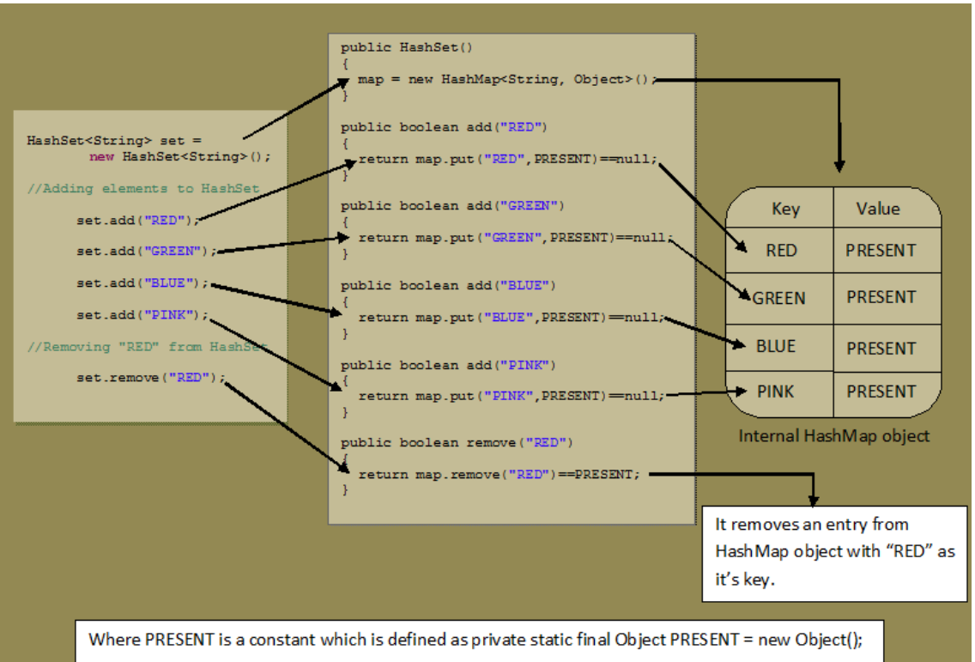
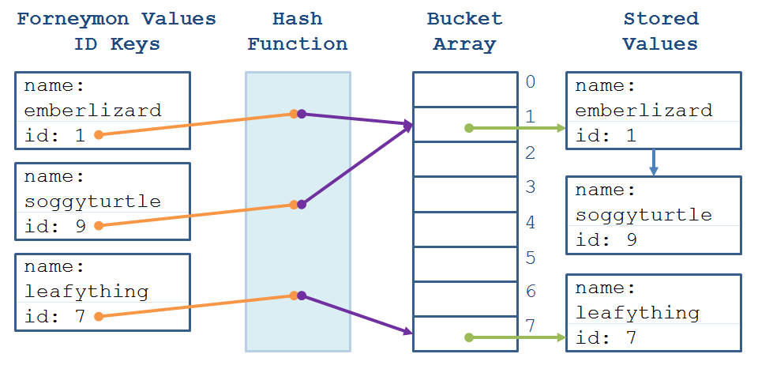
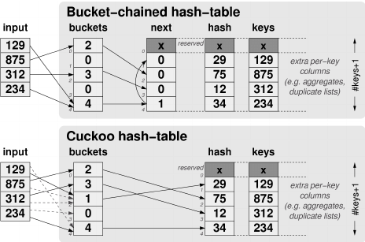

🔷 Core Concept
HashSet internally uses:
private transient HashMap<E,Object> map;
Yes.
HashSet is just a wrapper around HashMap.

🔥 How Does It Store Elements?
When you do:
Set<String> set = new HashSet<>();
set.add("Apple");
Internally:
map.put("Apple", PRESENT);
Where PRESENT is a dummy object.
So:
- Key = your element
- Value = constant dummy object

🔥 Internal Data Structure of HashMap
Before Java 8:
- Array of buckets
- Each bucket → Linked List
After Java 8:
- If bucket size > 8
- Converts to Red-Black Tree
Why?
To improve worst-case time from:
O(n) → O(log n)

🔥 Time Complexity
Operation | Average | Worst Case
add | O(1) | O(log n)
remove | O(1) | O(log n)
contains | O(1) | O(log n)

🔥 Important: hashCode() & equals()
HashSet depends on:
hashCode()
equals()
If you don’t override them properly,
duplicates may not be detected.
Interview favorite question.

🔥 Ordering
HashSet:
- Does NOT maintain insertion order
- Order is unpredictable

🔥 When To Use
- Need uniqueness
- Fast lookup
- Order doesn’t matter

2️⃣ LinkedHashSet
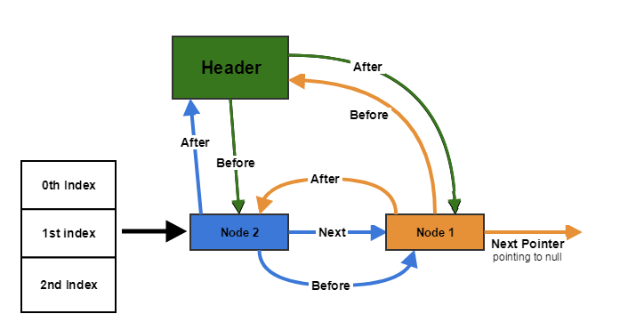
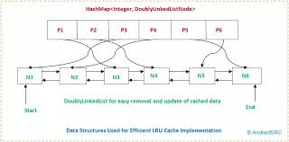
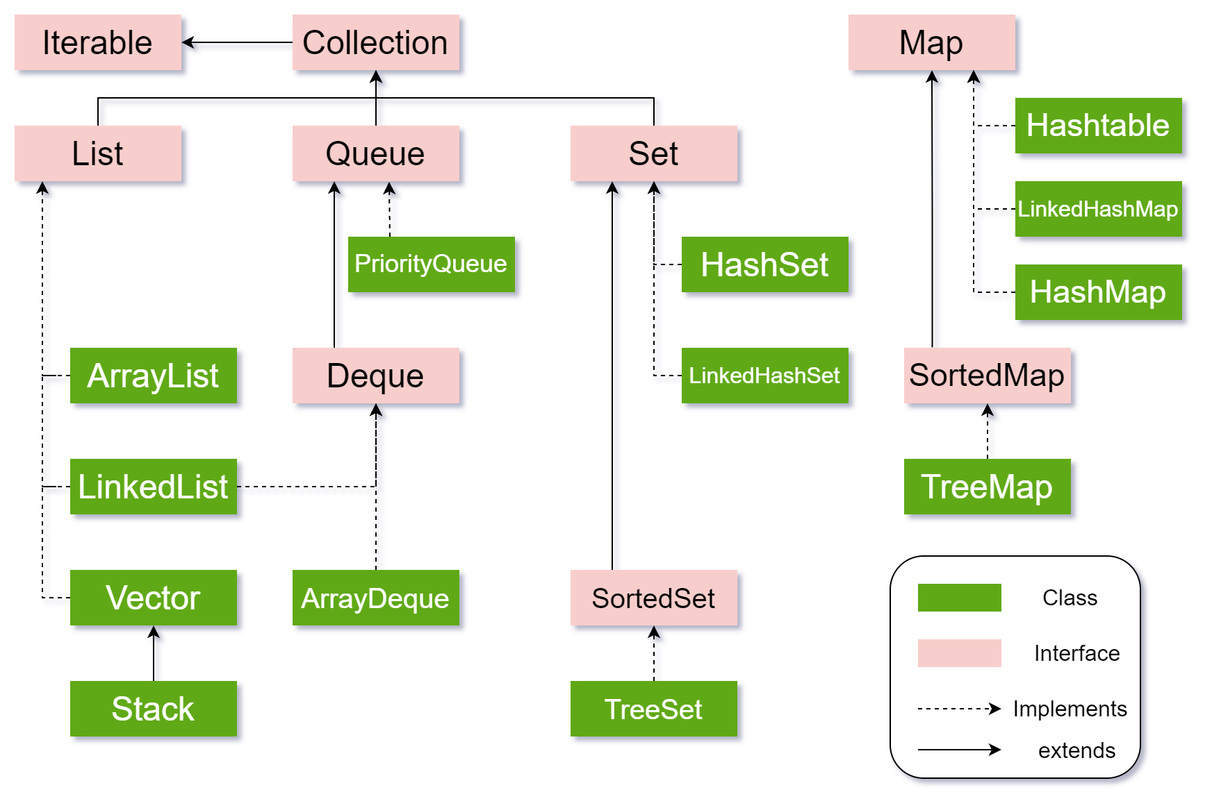
4

🔷 Internal Structure
LinkedHashSet uses:
LinkedHashMap
Which extends HashMap by adding:
- Doubly linked list to maintain order

🔥 What It Maintains
Insertion order.
Example:
Set<String> set = new LinkedHashSet<>();
set.add("B");
set.add("A");
set.add("C");
Output order:
B A C

🔥 Time Complexity
Same as HashSet:
O(1) average
But slightly slower due to maintaining linked list.

🔥 When To Use
- Need uniqueness
- Need insertion order

3️⃣ TreeSet

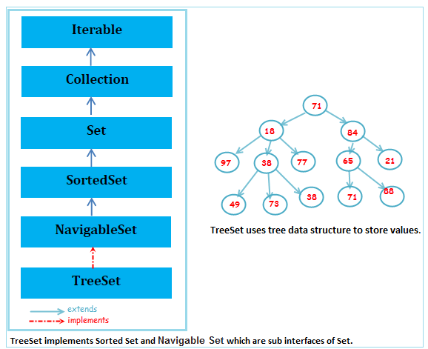
4

🔷 Internal Structure
TreeSet uses:
TreeMap
Which internally uses:
Red-Black Tree
Self-balancing binary search tree.

🔥 What It Maintains
Sorted order (natural ordering or custom comparator).
Example:
Set<Integer> set = new TreeSet<>();
set.add(5);
set.add(1);
set.add(3);
Output:
1 3 5

🔥 Time Complexity
Operation | Time
add | O(log n)
remove | O(log n)
contains | O(log n)
Slower than HashSet, but ordered.

🔥 Requires
Elements must be:
- Comparable
OR
- Comparator provided
Otherwise:
ClassCastException

🧠 Full Comparison Table
Feature | HashSet | LinkedHashSet | TreeSet
Duplicates | ❌ | ❌ | ❌
Order | ❌ | Insertion | Sorted
Internal DS | HashMap | LinkedHashMap | Red-Black Tree
Avg Time | O(1) | O(1) | O(log n)
Allows null | 1 null | 1 null | ❌ (usually no null)

🔥 Interview-Level Questions
Why is TreeSet slower?
→ Because tree operations are O(log n)
Why does HashSet need equals and hashCode?
→ To detect duplicates correctly
Why does LinkedHashSet use more memory?
→ Doubly linked list overhead

🎯 Real Backend Advice
Use:
Set<T> set = new HashSet<>();
Default choice.
Use LinkedHashSet when order matters.
Use TreeSet when sorted order is required.

-=-=-=-=-=-=-=-=-=-=-=-=-=-=-=-=-=-=-=-=-=-=-=-=-=-=-=-=-=-=-=-=-=-=-=-=-=-=-=-=
2.4 Set Implementations (Deep Internal Working)
Now we move deeper into Set implementations.
Remember from earlier:
Set → No duplicates allowed
Internally most Sets use hashing or tree structure.

1️⃣ HashSet

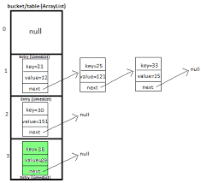
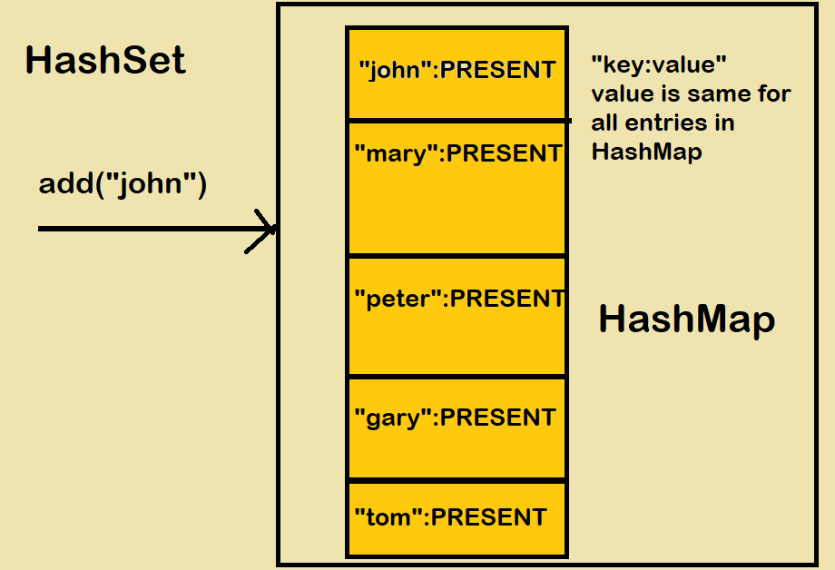
4
📌 Internal Structure
HashSet internally uses:
HashMap
Actually:
private transient HashMap<E,Object> map;
It stores elements as:
map.put(element, PRESENT);
Where PRESENT is just a dummy object.
So:
HashSet<String> set = new HashSet<>();
set.add("A");
Becomes internally:
HashMap:
"A" -> dummyObject

🔥 How HashSet Stores Data
Step 1: hashCode()
When you add:
set.add("Lakshay");
It does:
int hash = "Lakshay".hashCode();

Step 2: Index Calculation
index = hash & (capacity - 1)
This decides which bucket to go into.

Step 3: Collision Handling
If two elements have same index:
- Before Java 8 → LinkedList
- After Java 8 → LinkedList → converts to Tree (Red-Black Tree) if too many collisions (>8)

⏱ Time Complexity
Operation | Average | Worst
add | O(1) | O(n)
remove | O(1) | O(n)
contains | O(1) | O(n)
Worst happens during heavy collisions.

⚠ Why No Duplicates?
When adding:
set.add("A");
set.add("A");
It checks:
if(hash matches && equals() returns true)
Then it will NOT add again.
So duplicate prevention = combination of:
hashCode() + equals()
Very important for interviews.

2️⃣ LinkedHashSet

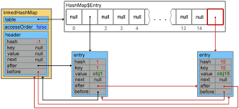
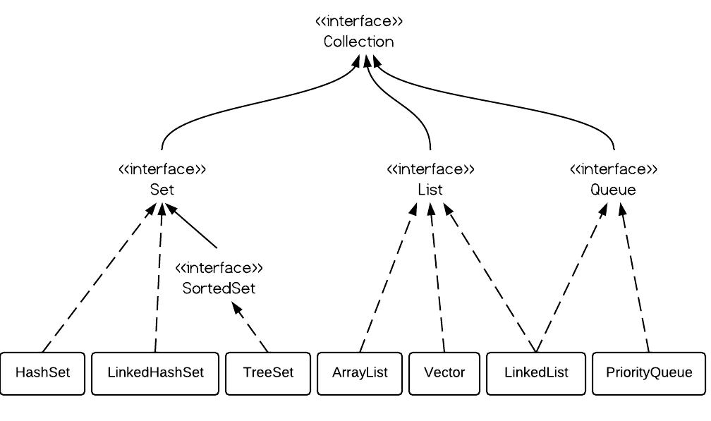
4
📌 What is Special?
Maintains:
Insertion Order
Internally uses:
LinkedHashMap
Which is:
HashMap + Doubly Linked List
So it keeps order using linked pointers.

🧠 Example
Set<Integer> set = new LinkedHashSet<>();
set.add(10);
set.add(5);
set.add(20);
Output:
[10, 5, 20]
Order preserved.

⏱ Complexity
Same as HashSet:
O(1) average.
But slightly slower due to maintaining links.

3️⃣ TreeSet

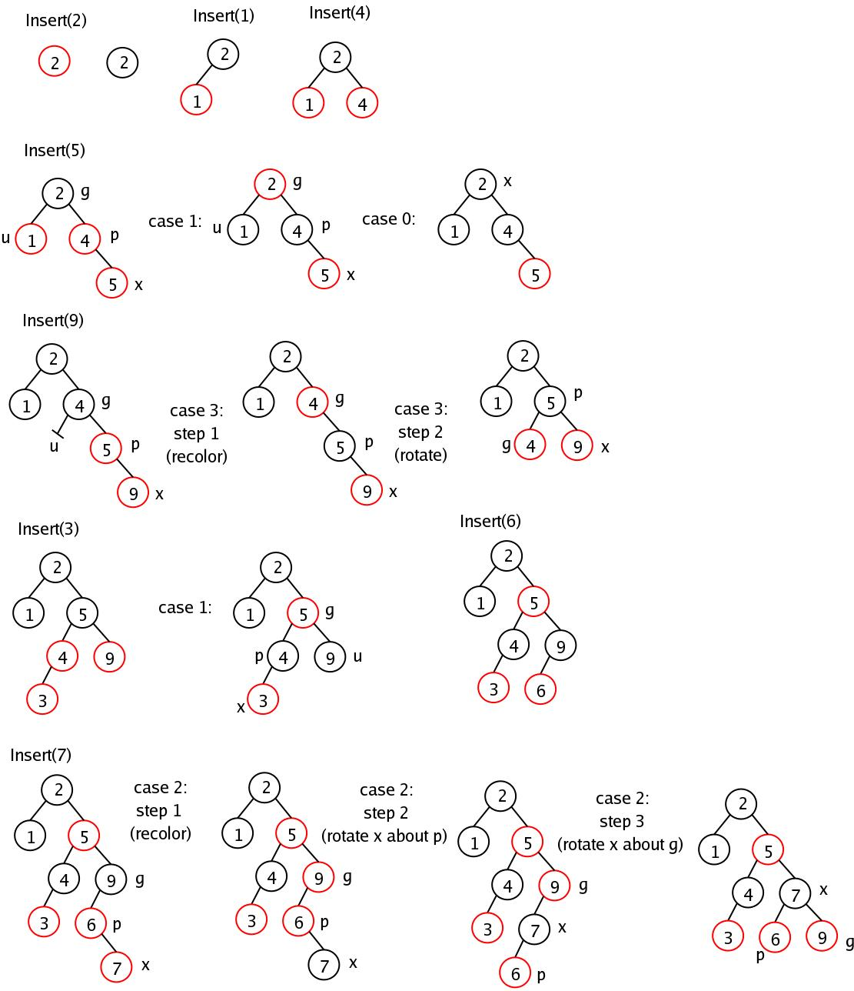

4
📌 Internal Structure
Uses:
TreeMap
Which internally uses:
Red-Black Tree
Red-Black Tree = Self balancing Binary Search Tree.

🔥 How It Works
When you add:
set.add(50);
set.add(10);
set.add(40);
It places elements according to:
Comparable OR Comparator
Then balances the tree.

🧠 Characteristics
Feature | TreeSet
Duplicates | ❌ Not allowed
Order | Sorted
Null allowed | ❌ No
Time Complexity | O(log n)

⚠ Sorting Rule
Either:
- Class implements Comparable
OR
- Provide Comparator in constructor
Example:
TreeSet<Integer> set = new TreeSet<>();
Automatically sorted.

🧠 HashSet vs LinkedHashSet vs TreeSet
Feature | HashSet | LinkedHashSet | TreeSet
Order | ❌ No | ✅ Insertion | ✅ Sorted
Speed | Fastest | Slightly slower | Slowest
Internal DS | HashMap | LinkedHashMap | Red-Black Tree
Complexity | O(1) | O(1) | O(log n)

🔥 When To Use What?
Situation | Use
Fast lookup | HashSet
Maintain insertion order | LinkedHashSet
Sorted data needed | TreeSet

⚡ Deep Internal Interview Question
Q: Why TreeSet is slower?
Because:
Every insertion requires tree balancing.
Balancing = rotations = O(log n)

🧠 Important Internal Concept
Load Factor (default 0.75)
If size > capacity × loadFactor → resize
Same as HashMap.

🎯 Key Interview Traps
- If you override equals(), you must override hashCode()
- Mutable objects inside HashSet → dangerous
- TreeSet doesn’t use hashCode()
- HashSet allows one null
- TreeSet does not allow null

